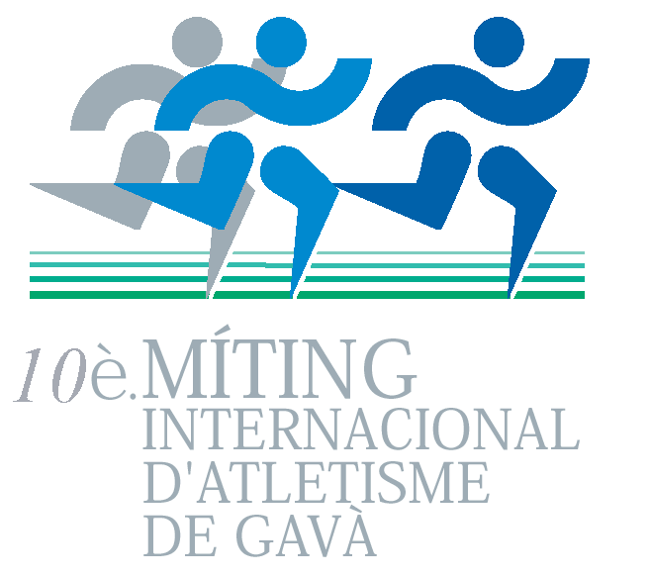

X MÍTING INTERNACIONAL D’ATLETISME

GAVÀ – BARCELONA-SPAIN

30/06/2007




EPREUVES – EVENTS

MEN | WOMEN
- 18:35 - Triple Jump  - 19:10 - 100 M  - 19:20 – High Jump  - 19:25 – Javelin throw  - 19:25 - 800 M  - 20:00 – Shot put  - 20:05 - 5000 M Race Walking  - 20:35 - 3000 Steeple  - 20:45 - 400 M  - 20:50 - 5.000 M  18 :30 -1500 Wheelchair | - 18:30 - Pole Vault  - 18:30 - Discus throw  - 18:40 - 100 M Hurdles  - 18:50 - 3.000 M Steeple  - 19:05 - 100 M  - 19:15 - 1500 M  - 20:00 - Long Jump  - 20:30 - 200 M  18 :30 -1500 Wheelchair

MINIMS – MINIMUMS

EVENTS | MEN |  | WOMEN
 | ENTER MINIMUMS | INVITACIÓN  MINIMUMS | ENTER MINIMUMS | INVITACIÓN  MINIMUMS
100 m. | 11.00 | 10.50 | 12.64 | 11.85
200 m. |  |  | 26.24 | 24.10
400 m. | 49.64 | 47.00
100 mh. |  |  | 15.00 | 13.50
800 m. | 1:52.5 | 1:48.00
1.500 m. |  |  | 4:42.0 | 4:19.0
5.000 m. | 14:15.00 | 13:35.00
3.000 m. Steep. | 9:10.0 | 8:35.00 | 11:30 | 10:30
Pole Vault |  |  | 3,30 | 3,70
Long Jump |  |  | 5,70 | 6,15
Triple Jump | 14,40 | 16,00
High Jump | 1,95 | 2,17
Shot Put | 16,00 | 19,00
Discus Throw |  |  | 39,00 | 50,00
Javelin Throw | 55,00 | 68,00
5000 m racewalking | 22,00 | 20,00

PRIMES – CASH PRICES
150 € | Prime au vainqueur de chaque epreuve  Cash price to the winner of each event
200 € | Nouveau record du stade  For a new stadium record
200 € | Nouveau record EAP  For a new EAP record

Premios – según tabla IAAF del 2005

- 500 € 6º.- 230 €
- 450 € 7º.- 200 €
- 375 € 8º.- 180 €
- 325 € 9º.- 160 €
- 275 € 10º.- 130 €

HORAIRE - TIMETABLE
HORAIRE - TIMETABLE
18,00 h. | Events Inauguration “ X Míting Internacional de Atletismo”
18,30 h. | Begining of International Meeting
21,30 h. | Finish of the Meeting

INFORMATION

PATRONAT MUNICIPAL D’ESPORTS GAVA:

Tel. : ++ 34 263 91 80 FAX: ++ 34 93 263 91 78
E mail: meeting@aj-gava.cat asolis@aj-gava.cat
www.gavaciutat.cat

Pre-register –pre-inscription – www.eap-circuit.org

LODGING:
Hotel Barcelona Classic
Ginesta 13 Castelldefels
Tel : ++ 34 93 636 06 08

ENGAGEMENTS AVANT – ACCREDITATION DEADLINE
22/ 06/ 2007

STADIUM RECORDS
 | Men
100 m | 10.41 | PATRICK JARRETT | JAM | 13/06/04
400 m | 46.06 | DAVID CANAL | ESP | 28/05/00
800 m | 1:47.78 | MIQUEL QUESADA | ESP | 26/05/02
5000 m | 13:14.38 | KIPRONO MENJO | KEN | 12/06/05
3000 m.steep. | 8:26.03 | DAVID CHEMWENO | KEN | 11/05/03
Javelin throw | 81,05 | AINARS KOVALS | LET | 12/06/05
Triple Jump | 16,66 | SAMUEL OKANTEY | GHA | 10/06/01
Hihg Jump | 2,21 | OLEG VOROBEI | BLR | 19/05/99
5000 m rw | 19:38.20 | J.ANTONIO GONZÁLEZ | ESP | 12/06/05
 | Women
110 mt | 13.59 | TATIANA MOURZAKOVA | RUS | 24/05/98
100 m | 11.41 | ANNA VOSKANIAN | RUS | 28/05/00
200 m | 23.51 | NATALIA PIGIDA | UKR | 13/06/04
3000 m.steep. | 10:01.62 | MEKDES BEKELE | ETH | 11/06/06
1500 m | 4:18.17 | EMILI CHIBET | KEN | 12/06/05
Long Jump | 6,39 | CAMILLA JOHANSSON | SWE | 24/05/98
Pole Vault | 4,20 | NAROA AGUIRRE | ESP | 11/05/03
Discus Throw | 56,69 | NATALYA FOKINA | UKR | 12/06/05

 |  | RECORDS EAP
100 m | 9.98 | Men  FRANCIS OBIKWELU | 78 | NIGERIA | BRAGA | 2000
400 m | 45.01 | ROBERT TOBIN | 83 | G.BRETANYA | GENEVE | 2005
800 m | 1:45.17 | ROBERT CHIRCHIR | 72 | KENYA | NIVELLES | 1996
3000 m.steep. | 8:22.16 | JOSE Mª GONZALEZ | 73 | ESPANYA | NAMUR | 1999
5000 m | 13:14.38 | KIPRONO MENJO |  | KENYA | GAVA | 2005
Triple Jump | 17,42 | NATHAN DOUGLAS | 82 | G.BRETANYA | GENEVE | 2006
Shot put | 20,61 | MIKULAS KONOPKA | 79 | SLOVAKIA | PALAFRUGELL | 2005
Javelin throw | 84,52 | VLADIMIR PORFIONOV | 70 | UZBEKISTAN | PALAFRUGELL | 1995
Hihg Jump | 2,28 | SERGEI KOLESNIK | 69 | UKRANIA | ODESSA | 1994
5000 m rw | 19:38.20 | J.ANTONIO GONZÁLEZ | 79 | ESPANYA | GAVÀ | 2005
 |  | Women
100 m | 10.99 | CHRISTINE ARRON | 73 | FRANÇA | GENEVE | 1998
100 mt | 12.58 | MARINA AZYABINA | 63 | RUSSIA | LYON | 1993
200 m | 22.85 | SYLVIANE FELIX | 77 | FRANÇA | GENEVE | 1997
1500 m | 4:07.76 | COURTNEY BABCOCK | 72 | CANADA | BRASSCHAAT | 2003
3000m.steep. | 9:52.66 | INES MONTEIRO | 80 | PORTUGAL | BILBAO | 2005
Pole vault | 4,41 | NASTIA RYJIKH | 77 | ALEMANYA | LUGANO | 2004
Long jump | 6,79 | EUNICE BARBER | 74 | FRANÇA | PIERRE BENITE | 1999
Discus throw | 64,14 | LARISA KOROTKEVICH | 67 | RUSSIA | LYON | 1993





 REAL FEDERACIÓN ESPAÑOLA
DE ATLETISMO




informa-te’n al telèfon gratuït
900 66 33 88
www.GavaCiutat.net

